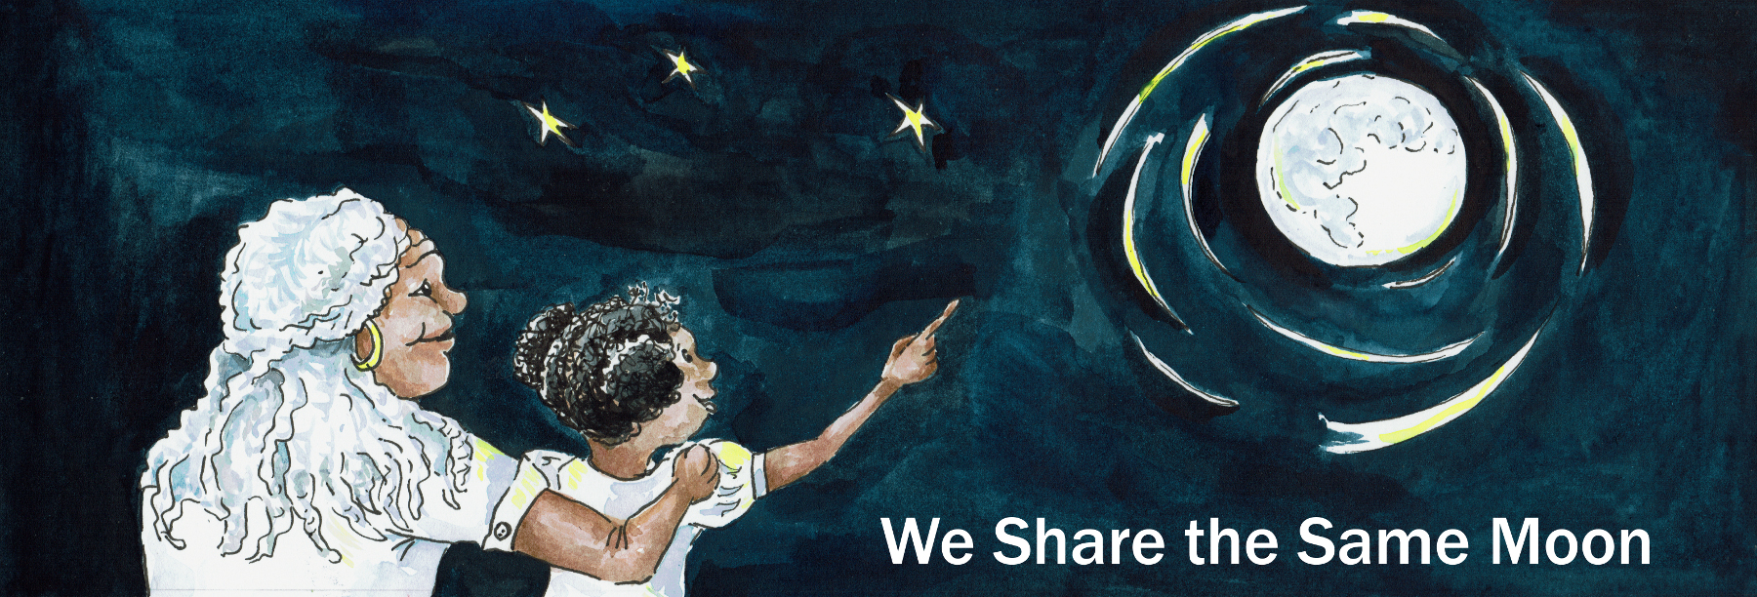
Suggested Age Range: 6 - 7 years: 7- 8 years; 8 - 9 years: 9 - 10 years; 10 - 11 years
Suggested UK Year Group: Year Four, Year Five
UK Curriculum: Key Stage Two (Lower); Key Stage Two (Upper)
UK Curriculum Links: States of Matter; Earth and Space
Science Subject: Stars
Science Question: Is the Sun a Star?
Suggested Science Activity: Star Hats; Solar System on a String
Children with SEND: Use with children to boost science vocabulary
EAL children: Intermediate Level
Country of Origin: First Nations of America
Source: Unknown (Heard in performance thirty years ago)

Long ago, when the world began. The world was perfect.
It was blue and green and perfect.
There was enough food, there was enough water, it was perfect.
All the animals and humans lived happily together, side by side.
Everything was perfect, perfect, perfect.

Except …
For one problem!
There was no light for the Sun had not yet been created.
And there was no heat, for Fire had not yet been discovered.
Everything was grey and there was NOTHING to keep the people warm.

And when the first winter came, and snow began to fall, it grew cold.
The very first people began to suffer.
The animals, well, they were Okay! They had feathers and fur to keep them warm.
But the very first people had nothing!
The people got colder and colder. They struggled to keep warm.
They wrapped their arms around themselves, they huddled together.
But it was no use!
They began to shiver, then their teeth began to chatter, then their bodies began to quiver.

What to do?
The animals wanted to help!
The Eagle wrapped her wings around the children.
The Bear gave bear hugs to as many as he could.
The Sheep huddled around the people to make a living blanket.
But it was no use! The people grew colder and colder and colder.
There was nothing they could do.

Except …
For one animal who had a cunning plan!
Coyote, the wild dog, he decided to be a hero!
For he knew that out-there in the yet to be discovered world.
There would be something that would keep the people warm.
And Coyote, with his sharp eyes and sharp ears and sharp nose.
Knew that he was the one to find it!

And so, across the frozen landscape he padded.
His paws crunching across the snow, sliding a little every now and then on the ice.
He walked and he walked and he walked for miles.

Until, he saw something! In the distance far away. An enormous mountain!
And, at the top of the mountain.
Something was burning, bright, orange, with flickering flames dancing up to the sky.
For Coyote had discovered fire! Wow! It was so bright, it burnt his eyes!
It smelt acrid. Ugh! It offended his nose!
But it was HOT! It was so hot, he could feel his fur begin to smoulder.
“This is what I want!” he whispered to himself.
“All I have to do is climb the mountain, grab a branch, bring it home and save the people. And then I will be a hero! Simple! “

What could go possibly wrong?

Coyote began to climb the mountain.
With his claws outstretched he pulled himself, from rock to rock to rock.
Up and up and up! Towards and past a bush.

When suddenly … ROAR!

A dragon appeared from behind the bush and chased Coyote down the mountain!
From rock to rock to rock he ran! All the way down the mountain!

What to do? Was he going to be beaten by a Dragon? NO!
He would find a way to creep behind the Dragon.
So, he crawled around the base of the mountain until he found another path, up and up and up. He sneaked past the Dragon, and then up and up even higher towards a tree.
When suddenly … ROAR!

A second dragon appeared from behind the tree and chased Coyote down the mountain! From rock to rock to rock he ran! All the way down the mountain!

What to do? Was he going to be beaten by two Dragons? This could be tricky! But NO! He wasn’t going to be beaten! Coyote tried again.
He waited until he heard both dragons were asleep.
The sound of their snoring echoed through the sky.
Then he sneaked as silently as he could, up and up and up, past one sleeping dragon, past two sleeping dragons, towards the fire.

When suddenly … ROAR!

A third dragon appeared from behind the fire and chased Coyote down the mountain!
His feet thumping from rock to rock to rock he ran! All the way down the mountain!

What to do? Was he going to be beaten by three Dragons? He thought long and hard. And then he sighed. Yes! He was beaten by three dragons.
How could one Coyote outwit three of them?

He so wanted to save the people and to be a Hero. But, “I can’t!”
He whimpered and slunk back home with his tail between his legs.

When he reached the camp, the other animals raced to meet him!
They were so excited!
But, then they saw his stricken face, they knew something was badly wrong!
“Well?” asked the animals
“Well” said Coyote. “I found something. And it was very warm! And I named it fire!
“And I tried to bring it home to you all.”
"But, there were three dragons guarding the fire and they wouldn’t let me take it!”
“So I came home. I couldn’t fight three dragons on my own!” “I am sorry, I failed you all"
“Oh silly Coyote “sighed the other animals.
“What made you think you had to be a Hero, on your own!”
“We will help you bring the fire down the mountain to keep them people warm!”

And so they made a plan.
Together, they crossed the frozen landscape.
Together, they walked and slid and flew towards the mountain.
Together, they huddled, waiting until the three dragons fell asleep.

Coyote crept up the mountain as silently as possible, past one, two, three dragons.
He crept closer and closer and closer to the fire.
He reached out to grabbed a branch. It was so hot! Arrgh!
But he knew he couldn’t make a single sound!
He put the burning branch into his mouth and then he turned.
And ran down the mountain as fast as he could!
His heart and feet pounding, he leapt from rock to rock, down and down and down!
And away across the frozen landscape, he streaked like lightening!

But, the dragons woke up and chased after him!
They were so enormous, each stride brought them closer and closer to Coyote.
Coyote could feel their fiery breath as it burnt his skin.
They grabbed hold of Coyote’s tail and …

“To me, to me, to me!” cried Eagle! “Throw the branch to me!”
Coyote threw the branch of fire! Up into the air towards the Eagle.
She swooped down, caught it in her beak and darted across the sky!
But, Dragons have wings! And they flew after her, their wings drumming against the air. Closer and closer and closer …
And then they grabbed her tail feathers and she cried out in pain!

And of course as she did cried out - she dropped the fire!

And it tumbled down and down and down towards a lake!
And what happens when fire meets water? It goes out!
“No!” cried the animals. What to do? There was nothing they could do!

Except
For one tiny animal, the frog!
She saw the branch of fire coming towards her. She leapt up into the air, grabbed it between her teeth and hopped as fast as she could!
But, frogs aren’t very fast.
And the dragons just reached out with their scaly claws and grabbed her tail and PULLED!
And frog knew that there was one thing and one thing only she could do!
She took a deep breath, jumped into the air … And left her tail behind her!
And from that day since, frogs have no tails, because of her part in this story.
Frog threw the fire towards a tree! And the tree swallowed it and the secret of fire whispered through its branches.

All the animals raced around the lake towards the tree.
Coyote looked up at the tree and the tree bent and shook two sticks down to Coyote. Coyote took the sticks and began to rub them together.
And what happens if you rub two sticks together?
First, there is a wisp of smoke! Then a flicker and then fire!

“Quick!” said Coyote, “Rabbits, you grab some dry grass and throw it on the fire!”
And the fire grew higher.
Quick” said Coyote, “Squirrels, you grab some branches and throw them on the fire!” And the fire grew higher.
“Quick” said Coyote, “Bears, you grab some trees and throw them on the fire!” And the fire grew higher. up and up and up towards the sky!
And this gave Coyote an idea!
He took a bundle of burning sticks and he rolled them together to make a ball of fire.
And then he threw the ball of fire up into the Sky!
And there it stayed!
To become the Sun, a burning ball of fire, that bring light and warmth to everyone!
And that is how Coyote, with the help of the other animals, created the Sun, long ago!

But is this story true?

Now scientists say that the Sun is a Star, made of gas.
And that the heat and light of the Sun is made from atoms of hydrogen colliding together in the process they call nuclear fusion.

But what do YOU think is true?

Copyright Cassandra Wye May 2019

